**Go and Java (Android)**

**Go binds to IOS as well**

To date we have looked at

* tool chain concepts
* object files
* static linking object files to a binary executable
* dynamic linking object files at runtime

In the professional domain you will need to extend these concepts to the idea of ‘[**cross compile**](https://en.wikipedia.org/wiki/Cross_compiler)’

host operating system → target system

**Embedded system programming**, Android is the major target system

Android is the more open and more customizable than iOS, that is more third party developer friendly

**Android** dominates the smartphone market with a share of 82.8%.

http://www.idc.com/prodserv/smartphone-os-market-share.jsp

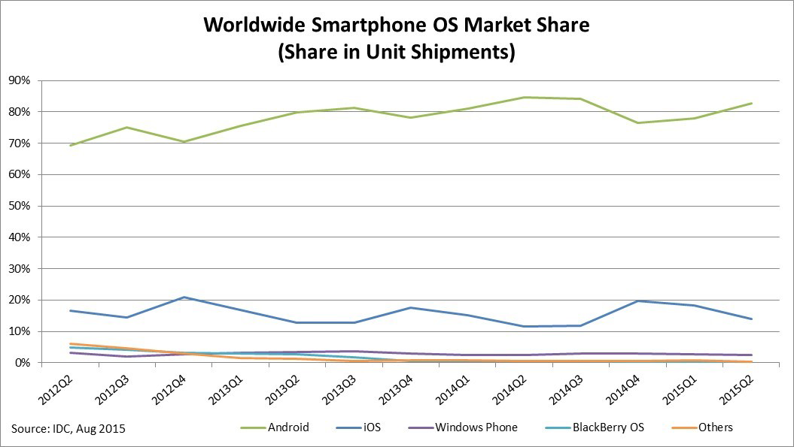

**Android system stack Java Layer and Native Layer**

Typical Android applications target the Application Layer. Sometimes you will hear of the the Service layer (between applications) Typically Java

Application Framework, Android Java implementation (Java 6) Java libraries

Libraries native service later, toolchain, good to know this

HAL ([Hardware Abstraction Layer](https://en.wikipedia.org/wiki/HAL_(software)))

Linux Kernel and Drivers

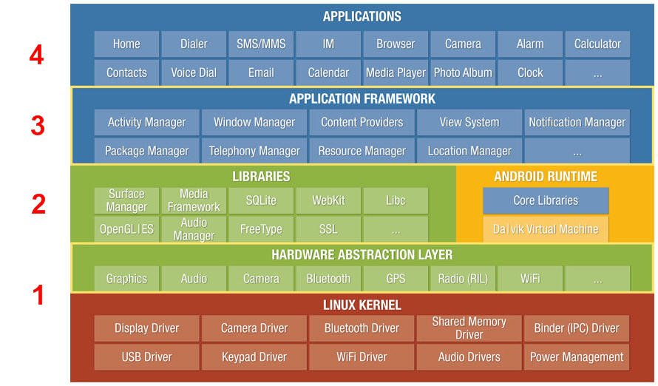

**GoLang have created Go Language bindings for the Android stack**

Fully utilizes all the tools in the Android native layer.

**Go mobile**

<https://github.com/golang/go/wiki/Mobile>

* Writing all-Go native mobile applications.
* Writing SDK applications by generating bindings from a Go package and invoke them from Java (on Android) and Objective-C (on iOS).

**Practical example**

1. **Install go mobile**

go get golang.org/x/mobile/cmd/gomobile

gomobile init

go get -d golang.org/x/mobile/example/basic

gomobile build golang.org/x/mobile/example/basic

gomobile build -target=android golang.org/x/mobile/example/basic

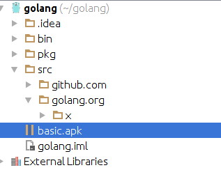

**Android**

**2. Install Android sdk**

<http://developer.android.com/sdk/installing/index.html>

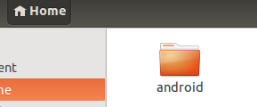

android sdk

<http://developer.android.com/tools/help/sdk-manager.html>

**3. Configure environment**

**.bashrc**

**source .bashrc**

**export ANDROID_HOME=/home/ubu/android**

**export PATH=$PATH:$ANDROID_HOME/tools:$ANDROID_HOME/platform-tools**

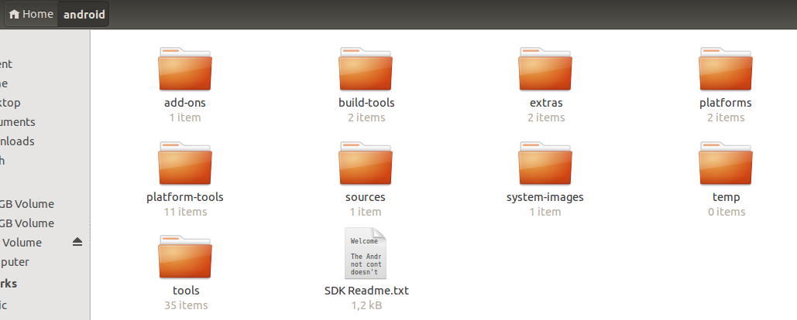

**3. Create emulator**

android avd

**4. Run code**

adb install basic.apk

